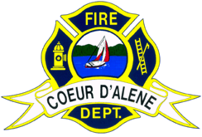

City of Coeur d’Alene

FIRE DEPARTMENT

“City of Excellence”

MEMORANDUM

Date: February 16, 2011

To: All Fire Department Personnel

From: Kenny Gabriel, Fire Chief

Re: Idaho Medal of Honor

It is with great pride I give you the news that Firefighters Dylan Clark and Nate Hyder have been awarded the State of Idaho Medal of Honor for their actions at an incident in Dalton Gardens in June of last year.

If you were not aware, Dylan and Nate were assigned to EMS 28 and were dispatched to a vehicle vs. structure. Upon arrival they found a vehicle had crashed into the home through the garage. There was significant smoke coming from the garage as the tires were still spinning. Debris was also flying wildly around the entrance to the garage. They donned their SCBA and, without the protection of a hose line (they were the only units on scene) forced entry into the car, turned the car off, and rescued the patient.

To be awarded this medal is a huge honor. Police officers and firefighters from throughout the State compete for the award and it is predominantly awarded to Law Enforcement. This time, it was not. The awards will be given out June 4th, at the State of Idaho Fallen Firefighter Memorial in Boise.
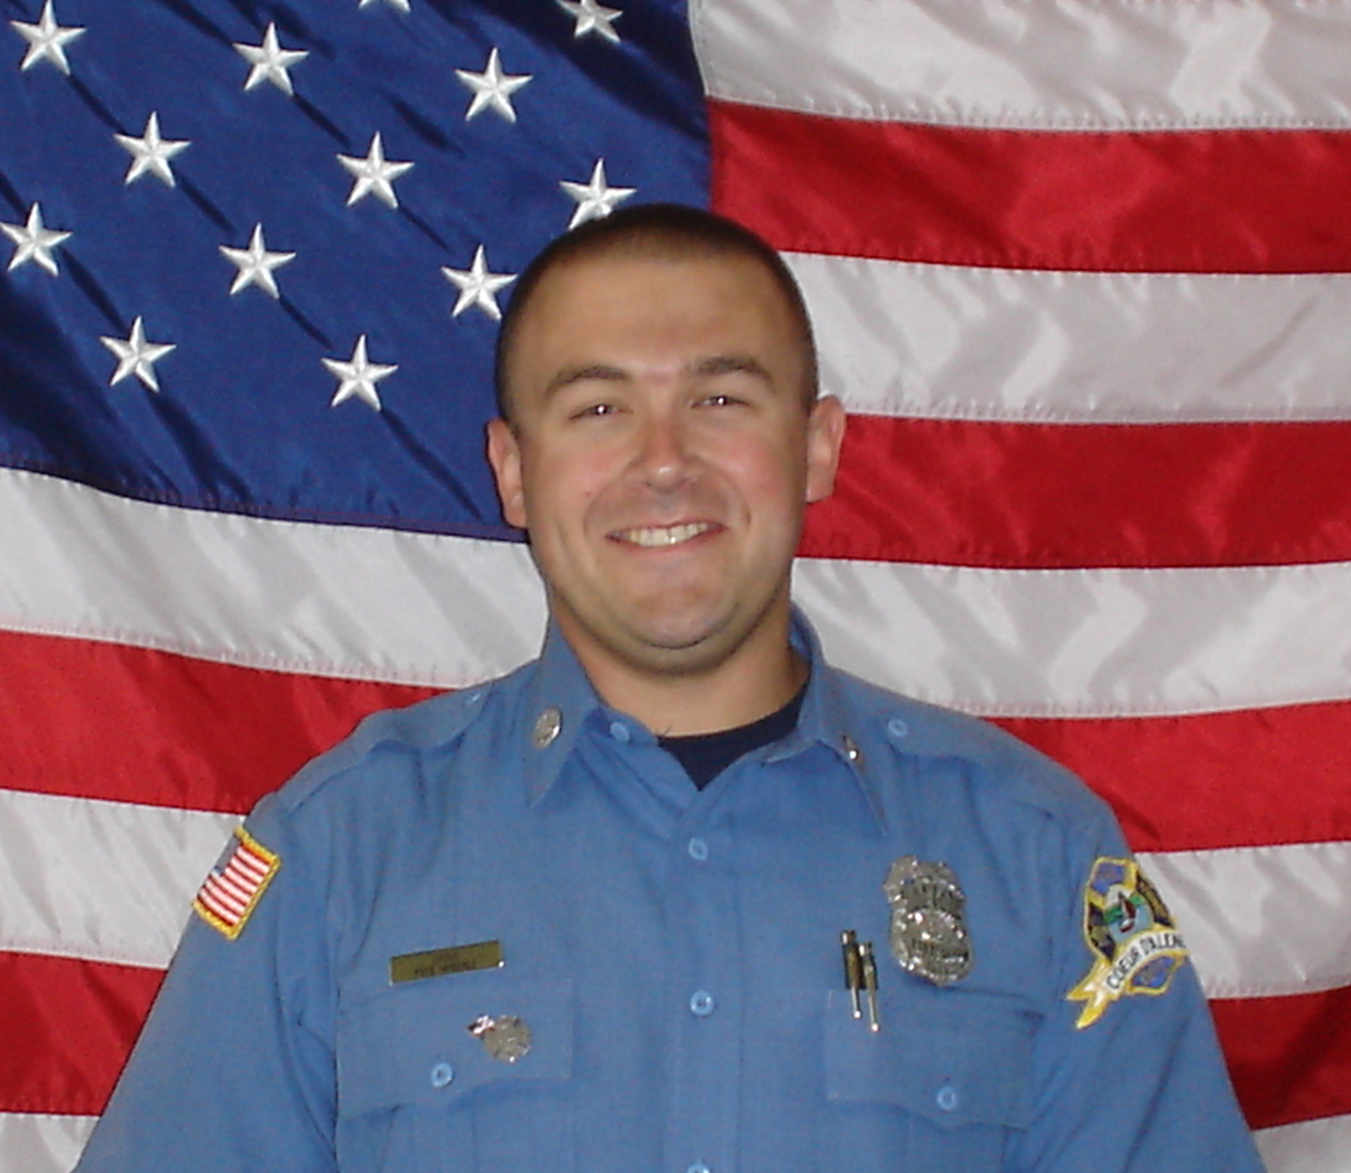
Well done Firefighters Clark and Hyder!!!!!

